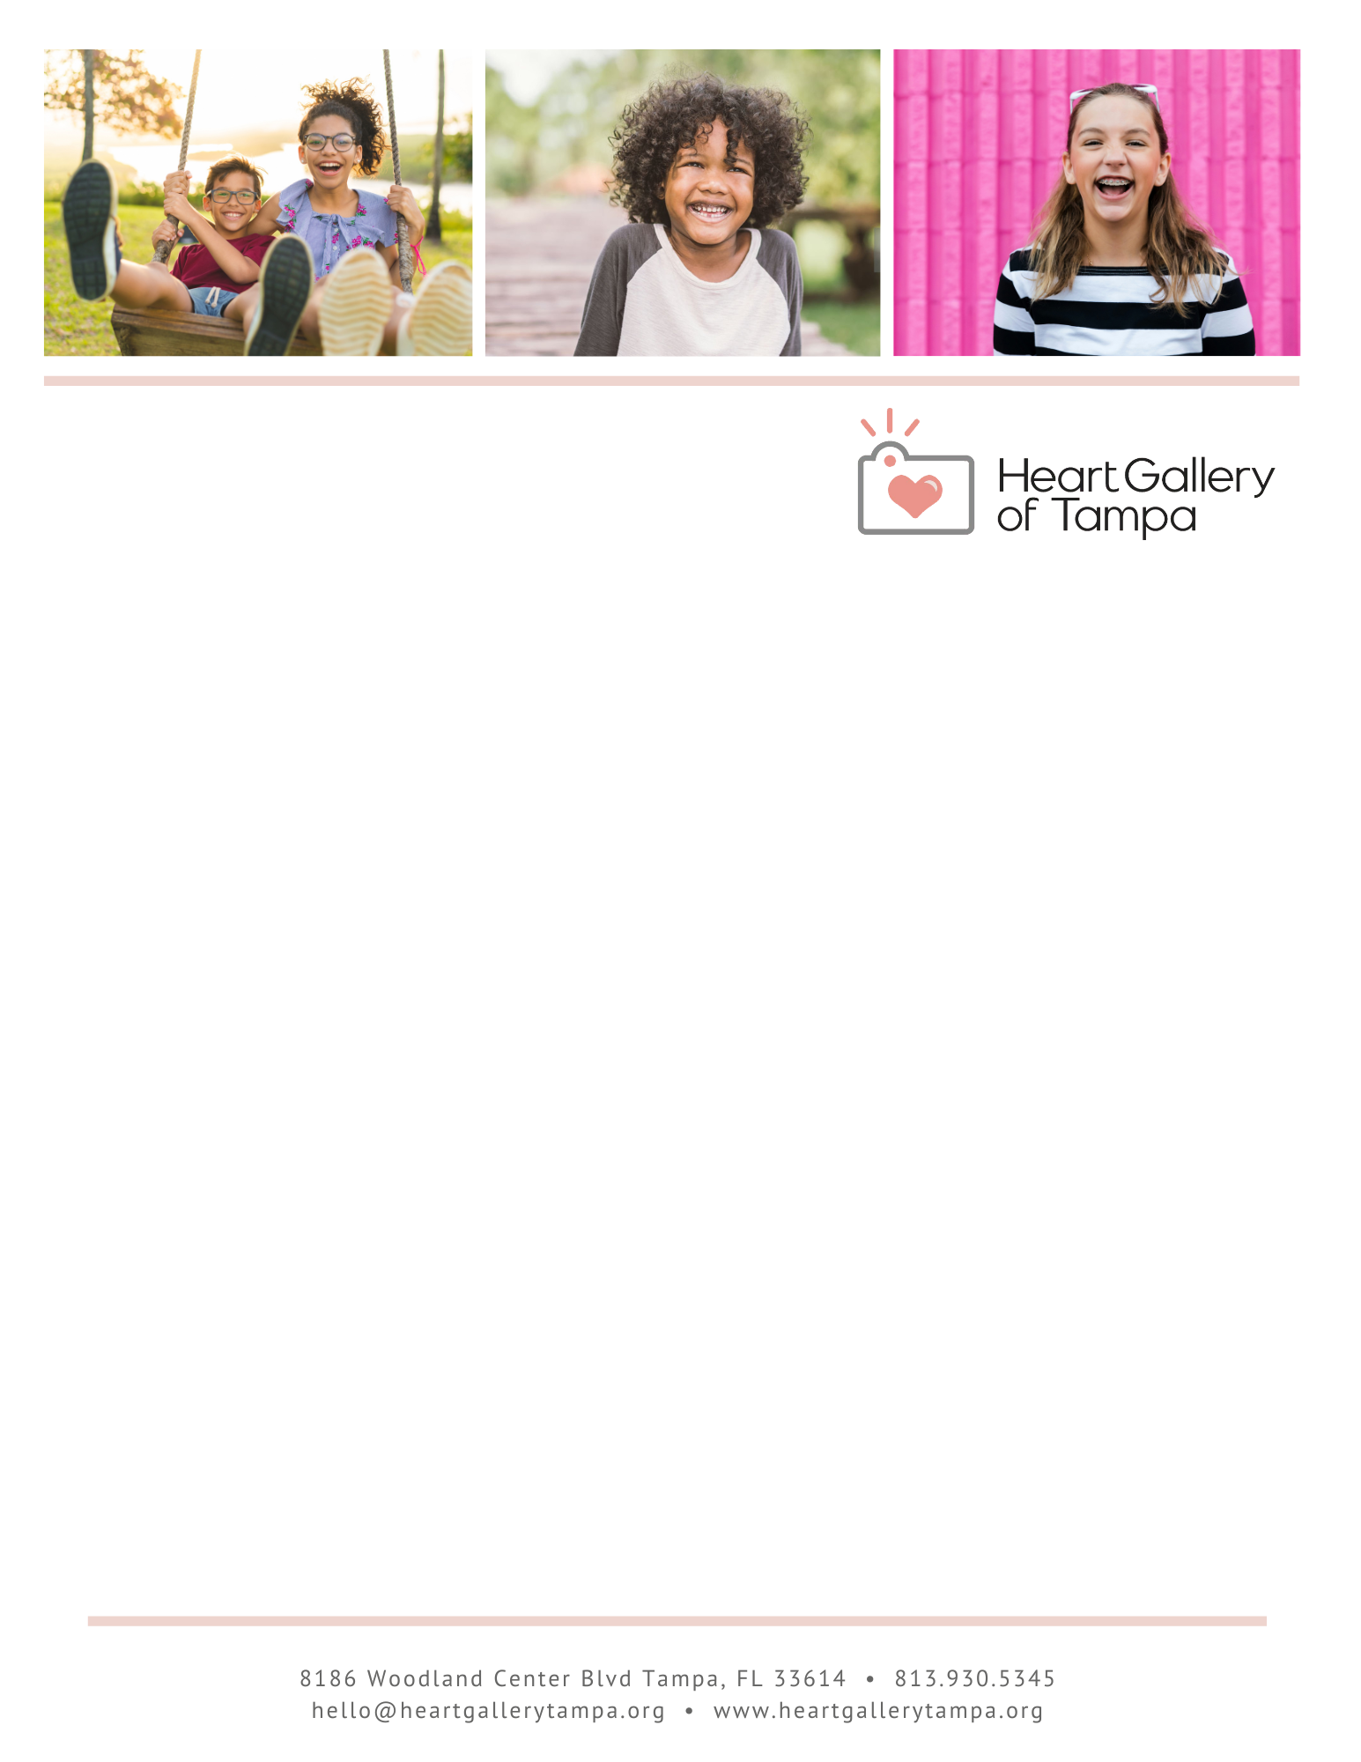

December 12, 2023

Hi Stefan,

I’m excited to introduce you to a local organization that’s making a BIG impact for foster children in Tampa! Through photography, videography, and traveling photographic exhibits, the Heart Gallery of Tampa introduces our community to foster children awaiting adoptive families. The Heart Gallery partners with local professional photographers who donate their time and talent to photograph children who are in foster care waiting to be adopted. Approximately 100 children are featured annually in the Heart Gallery’s traveling photographic exhibits and on the Heart Gallery website. The program also focuses on establishing community partnerships and fundraising to increase the quality of life for Heart Gallery children as they wait to be adopted.

Our volunteer committee is thrilled to host Be Mine 2026: A Million Dreams on Thursday, February 12, 2026 at Palma Ceia Golf & Country Club. This incredible event supports the work of the Heart Gallery and the children they serve.

Each year, our sold-out crowd of 400 guests eagerly anticipate our unique silent auction featuring the best of what Tampa Bay has to offer. Travel, VIP experiences, high-end jewelry, and treasured items from local businesses attract competitive bidding through our digital auction system. We need auction donors just like Tampa Marriott Water Street to ensure the many hopeful children still waiting for a family will one day have a place to call home.

Not only are you supporting a worthy organization, but your brand will also be prominently featured to a sold-out audience, (400 guests, 65% women, majority reside in South Tampa and surrounding suburbs, households of $200k + with a median age range of 40) at an event with an average annual reach of 4.6 million.

We would love to include a Free experience from The Candle Pour in Oxford in our Silent Auction this year.

We truly appreciate your consideration and look forward to hearing from you soon!

With gratitude,

