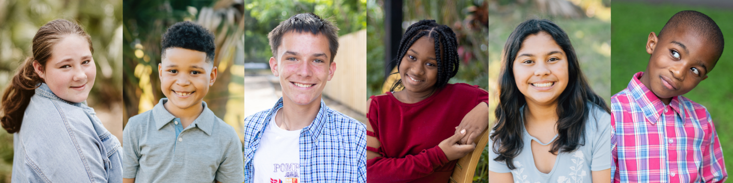

Dear ____________,

(It was great to see you last week at the ____________ event.... inquire about family members, informal hello’s up here.)

I’m excited to introduce you to a local organization that’s making a BIG impact for foster children in Tampa! Through photography, videography, and traveling photographic exhibits, the Heart Gallery of Tampa introduces our community to foster children awaiting adoptive families. The Heart Gallery partners with local professional photographers who donate their time and talent to photograph children who are in foster care waiting to be adopted. Approximately 100 children are featured annually in the Heart Gallery’s traveling photographic exhibits and on the Heart Gallery website. The program also focuses on establishing community partnerships and fundraising to increase the quality of life for Heart Gallery children as they wait to be adopted.

Our volunteer committee is thrilled to host Be Mine 2024: Don’t Stop Believin’ on Thursday, February 15, 2024 at Palma Ceia Golf & Country Club. This incredible event supports the work of the Heart Gallery and the children they serve. Be Mine has sold-out since the inaugural year and is a much-anticipated event in Tampa Bay. Events are designed around a new theme each year, involving costumed characters, special entertainment, interactive photo scenes, delicious food, and open bars. This signature event features a best-of-the-best silent auction, a high-end live auction, and an emotional program sharing stories of adoption and the power of love.

We need sponsors just like _________________ to ensure the many hopeful children still waiting for a family will one day have a place to call home. Not only are you supporting a worthy organization, your brand will be prominently featured to a sold-out audience, (500 guests, 65% women, majority reside in South Tampa and surrounding suburbs, households of $200k + with a median age range of 40) at an event with an average annual reach of 4.6 million.

Enclosed are Sponsorship Levels, information on branding opportunities, and the significant impact of your donation.

I truly appreciate your consideration and hope to see you at Be Mine 2024: Don’t Stop Believin’.

With gratitude,
(Your name here + contact info)

